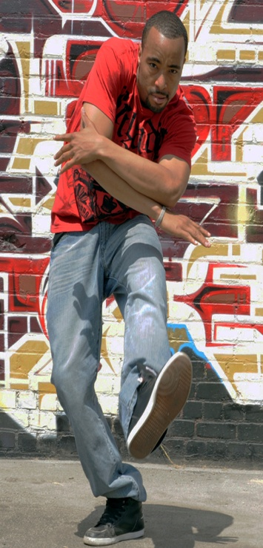
Guest Master Instructor/choreographer Markus Shields is coming to Kick It Out! Dance Studio

You have seen him on Season 4 of the hit dance show So You Think You Can Dance and Markus Shields’ choreography was praised and applauded by producer Nigel Lythgoe. In Season 10, he was one of 26 finalists making it through ‘Vegas Week,’ enjoying national recognition in that spotlight.
Come and take a class with him at:

KICK IT OUT! DANCE STUDIO
1880 HASLETT ROAD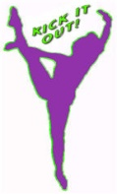 SUITE F – EAST LANSING 48823
Saturday, July 26, 2014

While Markus developed his versatile and hard-hitting hip-hop style through instruction of the urban students in his hometown, he studied ballet and jazz at Grand Rapids Community College. His interest in developing lasting relationships with dance organizations along with the high energy he brings to each piece he performs/choreograph certifies his as a strong master instructor/choreographer.

Two classes available on July 26, 2014:
1:00 pm – 2:00 pm Beginner Hip-Hop ages 7-12 $30 per student per class
2:15 pm – 3:15 pm Advanced Hip-Hop, ages 13+ $30 per student per class

Class registration fee includes class instruction with Markus, followed with a photo opportunity and questions with Markus.

You can pre-register and pay at www.kickitoutdance.com -- OR –-
Print, fill out and send the form below with pre-payment, address at bottom of registration portion.
All registered students are required to fill out a release and waiver of liability to participate.
--------------------------------------------------------------------------------------------------------------------------------------
REGISTRATION FORM
Student Name ____________________________________________ Phone: ______________________
E-mail: ______________________________________________________________________________
Address ____________________________________________ City __________________ ZIP:_______
Check Enrollment Requests: ____ Beginner Youth/JuniorHip-Hop $30
____ Int/Adv ages 13+ Contemp-Hop $30
Total # classes desired: ______ X $ = Total class fees: $ ___ _____
Total Enclosed $ _____________

Send form and check payable to: Kick It Out! 1880 Haslett Rd. Suite F East Lansing, MI 48823

Kick It Out!, LLC Release and Waiver of Liabilities

Name of Student: ____________________________________________

Indicated in the space below are any pre-existing health problems or conditions suffered by my child of which Kick It Out!, LLC should be aware (such as medical, allergy, muscular issues, pregnancy, diabetes, epilepsy, chemical or neurological conditions, special medications, heart, back, knee or shoulder problems, etc.). I understand that risk of injury is inherent in any physical activity and I, on behalf of myself and or my child, knowingly and voluntarily accept that risk. I, the undersigned, for myself and my heirs, administrators, successors, assigns and executors hereby waive, release and indemnify Kick It Out!, LLC along with its directors, instructors, independent contractors, staff and agents from any and all claims or damages of any kind, both foreseeable and unforeseeable, arising out of my child’s participation in any program or event offered by Kick It Out!, LLC. This shall include, but not be limited to, participation in any classes, competitions, evaluations and travel to any events, competitions or classes held by Kick It Out!, LLC. I further certify that the aforementioned student is in proper physical condition to participate in any program offered by Kick It Out!, LLC and that he/she has been examined by a licensed physician and found to be in proper physical condition to participate in any program offered by Kick It Out!, LLC. I hereby authorize Kick It Out!, LLC and its directors, instructors, independent contractors or agents to obtain medical treatment for my child in emergency situations where I cannot be reached in time to authorize the treating physician to provide such emergency medical services as may be necessary for my child. I understand I am responsible for any medical expenses in the absence of adequate medical insurance and that the absence of medical insurance does not make Kick It Out!, LLC responsible for payment of any medical expenses whatsoever related to my child. This authority includes the power to authorize any and all treatment deemed necessary under the circumstances by a licensed physician. This power is in essence a limited power of attorney and shall remain in effect for one year from the date signed below or so long as my child is enrolled in any program offered by Kick It Out!, LLC.

I hereby give permission for Kick It Out!, LLC to use any photography and or video of my child/children from events held within the studio or at functions hosted offsite by the studio for promotional and /or advertising purposes, including picture postings on the internet and social media. I have read and understand all rules and regulations of Kick It Out!, LLC and hereby assume all responsibility of said student or participant.

PARENT/GUARDIAN SIGNATURE:___________________________________________________________________
(If student is 18 years of age or older please sign and print name on form for self)

PRINTED NAME: ____________________________________________ DATE:______________________________

WITNESS SIGNATURE (Must be 18 years of age): ______________________________________________________

WITNESS PRINTED NAME: ________________________________________________________

EMERGENCY INFORMATION:

Physician Name: _______________________________________ Hospital Preference: _______________________________________________

Insurance Company and Policy Number: _________________________________________________________________________________________

Allergies to medications and medications currently taken: ____________________________________________________________________________________________________________________

____________________________________________________________________________________________________________________

Additional Health Information or Pre-Existing Conditions including Allergies: ________________________________________________________________________________________________________________________

